Whalebone Building and Garden Supplies

Sungate, Collier Row Road, Romford, RM 2BH

01708 740724

Woven Geo Fabric
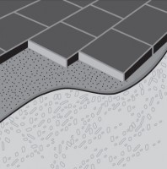
This hard-wearing closely woven fabric successfully meets the demands of soft and hard landscaping. works above ground as a heavy duty weed barrier, built to last for long term weed suppression. Having good tear resistance makes also suited for use below ground as a stabilising and separating membrane in groundwork and civil engineering applications.
Woven Geo Fabric can be used as a heavy duty weed control membrane or as woven geotextile fabric for ground stabilisation.
Available in a wide range of sizes, including widths up to 4.5 metres.
CODE | PRODUCT | SIZE | PER
GWF0 | Mini Roll | 1.0m x 15m | roll
GWF02 | Mini Pack | 2.0m x 10m | pack
GWF1 | Midi Roll | 1.0m x 50m | roll
GWF05 | Midi Roll | 1.5m x 50m | roll
GWF22 | Midi Roll | 2.0m x 25m | roll
GWF2 | Midi Roll | 2.0m x 50m | roll
GWF10 | Maxi Roll | 1.0m x 100m | roll
GWF20 | Maxi Roll | 2.0m x 100m | roll
GWF45 | Contractor Pack | 4.5m x 11m | pack
GWF450 | Contractor Roll | 4.5m x 100m | roll

